ID-24101203

Task3: The graph of Throughput vs Packet size

Here are the screenshots for the output with the packet size -2410,1023,124,3021

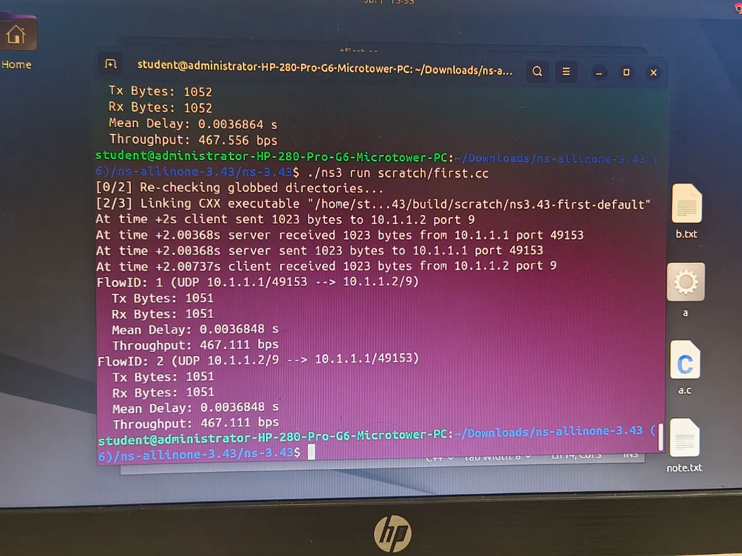
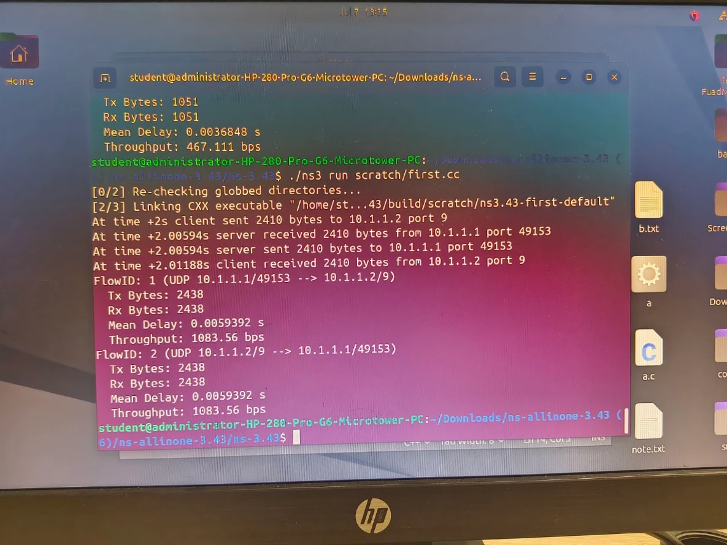
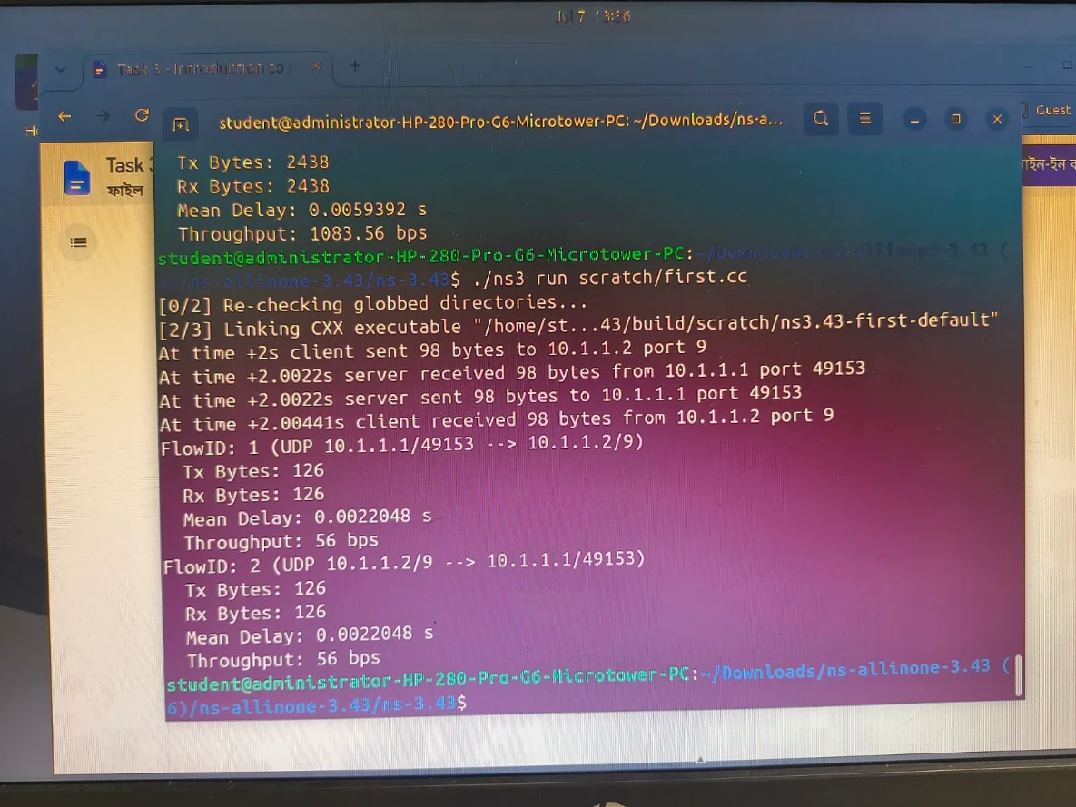
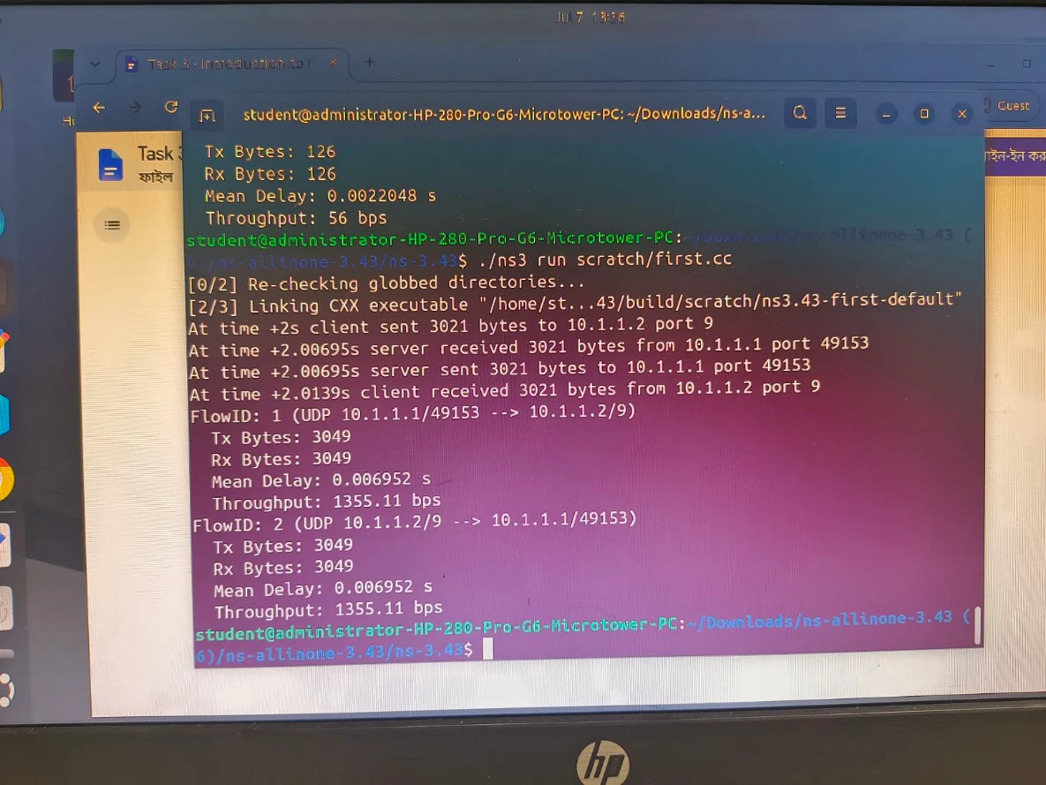

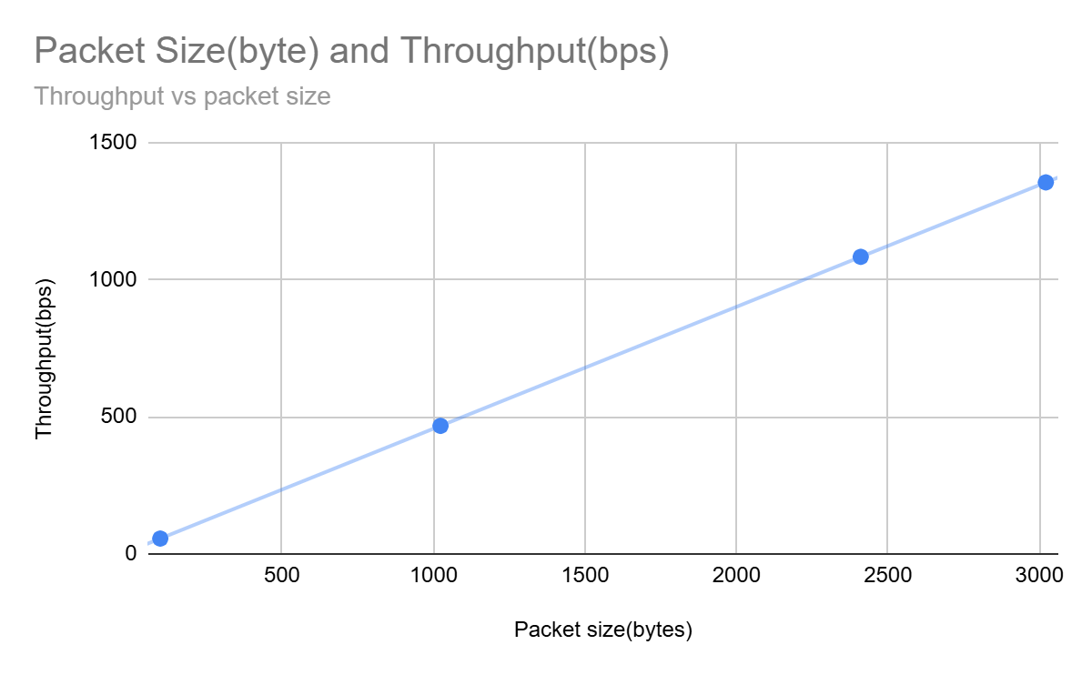
Here the graph is plotted using my studentID for four packet sizes with the given combinations . Here we can see the throughput is increasing almost linearly as the packet size increases from 56 bps at 98 bytes to 1355.11 bps at 3021 bytes . Because of the packets having fixed overhead(headers). So, when the packet size grows , that overhead gets a smaller fraction of the total transmission. It lets the useful data get through per unit time more.

